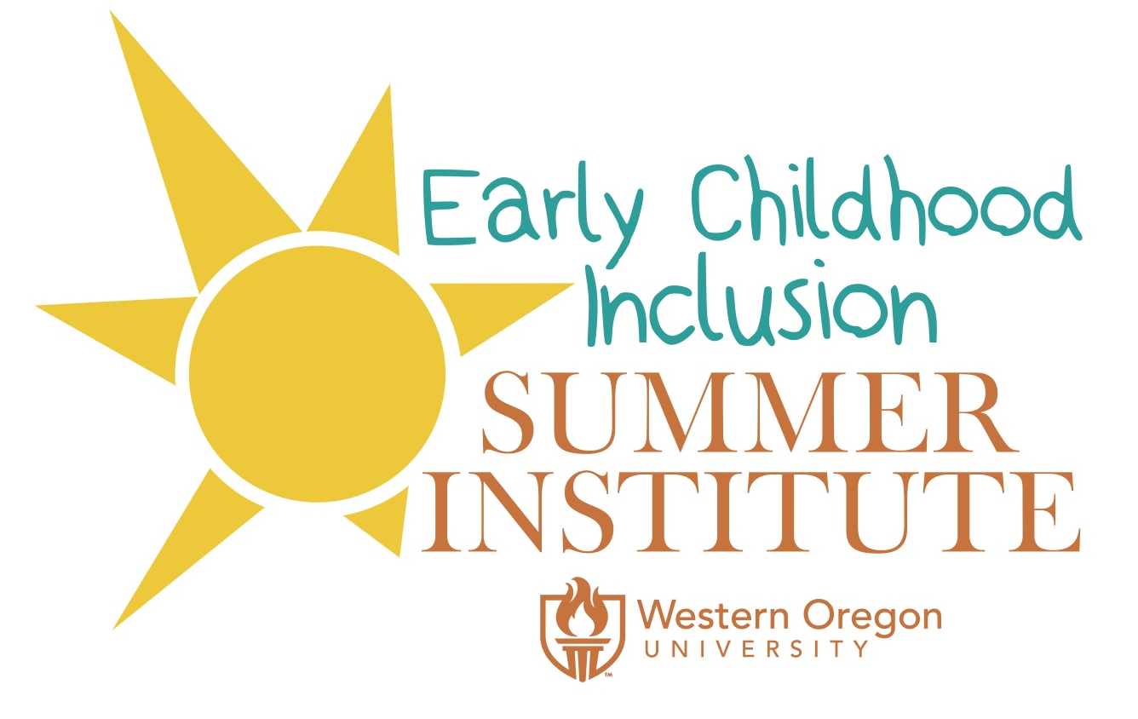
In a World of Ordinary Mortals, You are an Early Childhood Professional:
Let’s Celebrate You!
August 8-10, 2018
Western Oregon University
Call for Student Poster Session Proposal

Proposal Due Date: June 1, 2018

Email proposals to:
Dr. Cindy Ryan, Early Childhood Inclusion Summer Institute Director
ryanc@wou.edu

Please visit the conference website at: wouecisummerinstitute.com
_________________________________________________________________________________________________

Background:
The fifth annual Early Childhood Inclusion (ECI) Summer Institute at Western Oregon University (WOU) brings together early childhood and early intervention/early childhood special education pre-service and practicing teachers, as well as families of young children on the WOU campus for quality professional development, collaboration, and celebration. Our theme, In a World of Ordinary Mortals, You are an Early Childhood Professional: Let’s Celebrate You!, promises to bridge theory and practice by providing participants with workshops that provide them with innovative strategies and ideas to bring back to the classroom and/or home.

Early Childhood Inclusion Summer Institute Goals:
- To bring together families, students, early childhood and early childhood special educators and their teams in order to build trusting and collaborative relationships that support all young children in inclusive settings.
- To provide professional development around early childhood inclusion that reflects best practices, support practical strategies and ideas, and empowers families and early childhood/early intervention and early childhood special educators from all backgrounds.
- To celebrate the hard work and dedication of all those who love, raise, and educate young children.

Potential Student Poster Session Topics:
- Promoting the field of early childhood
- Teacher self-care and reflective practice
- Leadership in early childhood
- Innovative strategies & classroom practices (social-emotional, inclusive practices, and more)
- STEM (integrating STEM in inclusive classrooms, assistive technology, etc.)
- Workshops specifically for families (advocacy, transition, etc.)
- Diversity in early childhood environments
- Screening and Assessment
- Collaboration & Consultation
- Transition (between birth-3 and preschool, & preschool to kindergarten)
- Supervision
- Other poster ideas related to research in early childhood and EI/ECSE inclusion are welcome

Age Level:
- The ECI Summer Institute seeks proposals, which address the age range from infancy though age nine. Proposers are asked to identify the following age levels:
Birth-2yr., Birth-5yr., 3-5yr., 5-9yr., Birth-9yr.

Submission Requirements:
- Submit complete poster session application to ryanc@wou.edu by 6/1/18
- Include the following:
- Completed application form
- Application must include all required elements

Proposal Review Process:
The Early Childhood Inclusion Summer Institute Poster Session Committee will begin to review proposals on May 9th and notification emails will be sent out by June 1st.

Poster Session Selection Criteria:
- Relevance of the topic to the goals and theme of the Summer Institute
- Quality and clarity of the poster description and stated learning objectives
- Originality and creativity

Poster Format:
Student posters may present research, teaching strategies, curriculum highlights, policy issues, comparative studies, etc. Special attention and priority will be given to posters focusing on issues related to the theme of the Summer Institute.

Posters should be prepared for display on a poster board (3'x4'), can be a tri-fold or a professional laminated poster (to be hung up).
Every designated poster session space consists of
- A rectangular table where visual displays may be displayed
- A backboard (bulletin board material) to hang posters
- Electricity will not be available for poster sessions.
- Presenters will need to provide items such as tacks, stables, and tape for mounting any display items

Poster sessions will be 75 minutes in length. There are many ways to present a poster session. Your presentation will depend on the type of research, instructional strategies/practices, etc. you will be presenting. You display should include:
- Poster Title
- Presenter(s) names
- Illustrations, tables, graphs, & photographs
- Text should be large enough to enable participants to read them from 3-6 feet, and use titles for each section
- Stick to a limited number of main points on your poster. You can elaborate on these points in your conversation with others
- Include handouts (we suggest at least 50 copies)
- Be ready to greet each person who approaches your board, anticipate questions and answers. In addition, be ready to ask questions to draw people into your conversation
- It is important that you remain with your display for the duration of the session (75 minutes). Much of the success of poster sessions is related to the presence of the presenter. Interaction and conversation between the presenter and the people attending the poster session are vital.
- Include handouts (we suggest at least 25 copies) and/or business cards
- Include other visuals (different from your poster) and technology as needed

Submission Guidelines:
Please submit via email or by regular mail the following:
- Cover page including:
A. Title
B. Presenter(s) contact information (name, addresses, phone numbers and email addresses) Include any co-presenters, including faculty. Authors will be contacted via email.
C. Community College/University that student is attending & your major
- Proposal description (1-page maximum) including:
A. Title
B. Goals of the Summer Institute to be address in this proposed session
C. Abstract (of your research, classroom strategy, etc.) to include:

Submission Deadline:
Proposals must be received by June 1, 2018. Announcements of acceptance of poster proposals will be sent by June 15, 2018.

Mail or email all proposal and attached documents to:
Dr. Cindy Ryan
345 N. Monmouth Av.
Monmouth, OR 97361
Email: ryanc@wou.edu

